MALL CUSTOMER SEGMENTATION

Problem statement
A mall owner wants to categorize customers based on their spending patterns, age, income, and behaviour. So, he asked a machine learning engineer to build a customer segmentation solution for the mall.

PREDICTION GOAL
Industry: Target Marketing
Step 1: domain selection - Machine learning
Step 2: learning type – Unsupervised Learning
Step 3: clustering

Tell basic info about the dataset
No of rows: 200
No of columns: 5
Important Features: Annual Income (k$), Spending Score (1-100)

All the research values of each algorithm

K means clustering
The Mall Customer dataset was analyzed using the K-Means clustering algorithm.
The optimal number of clusters was determined using the Elbow Method, where the minimum WCSS (inertia) was observed at K = 5.
A K-Means model was built with five clusters, and customers were successfully segmented into these groups.
The clustered data was saved as separate CSV files for further analysis.
Based on income and spending behavior, clusters 0, 1, and 2 were identified as the target customer segments.
Model performance was evaluated using clustering evaluation metrics and visual inspection, confirming that the model produces meaningful and well-separated clusters.

Agglomerative clustering
The dataset was also analyzed using Agglomerative Hierarchical Clustering.
A dendrogram was used to determine the optimal number of clusters. Since each data point starts as an individual cluster, the Ward linkage method was applied to measure inter-cluster distances.
From the dendrogram, the optimal number of clusters was identified as 5, and the model was built accordingly.
The resulting clusters were similar to those obtained from K-Means, with clusters 0, 1, and 2 identified as the target customer segments.
Model performance was evaluated using the Silhouette Score, which showed results comparable to K-Means, indicating good clustering quality.

Affinity propagation clustering
The dataset was further analyzed using Affinity Propagation clustering.
Unlike K-Means or Hierarchical clustering, Affinity Propagation does not require specifying the number of clusters in advance; instead, it determines clusters based on exemplars, controlled by the preference parameter.
Preference values were derived from the similarity matrix computed using pairwise distances, and the minimum, median, and maximum values were tested.
By tuning the preference parameter, a configuration producing 5 clusters was selected.
The model successfully identified five clusters, with performance evaluated using clustering metrics, achieving a score of 0.5, which is comparable to the K-Means model and indicates good clustering quality.
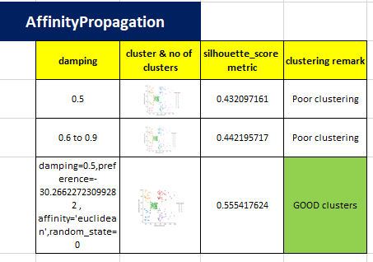

BIRCH clustering
The dataset was also clustered using the BIRCH (Balanced Iterative Reducing and Clustering using Hierarchies) algorithm.
Key hyperparameters such as the branching factor and threshold were tuned, with the number of clusters set to 5.
The branching factor was fixed at 50, and threshold values 0.5 and 0.4 were evaluated.
At 0.5, one cluster was not well separated, while at 0.4, all five clusters were clearly separated.
Visual inspection confirmed customer segmentation similar to other clustering algorithms.
The model showed good performance, with evaluation scores around 0.5 (nearly to 1), indicating good clustering.

DBSCAN clustering
The dataset was also analyzed using DBSCAN (Density-Based Spatial Clustering of Applications with Noise).
The epsilon (ε) parameter was determined using the k-distance graph, with a stabilized value of 0.5.
The model produced three clusters, of which two were well-separated and the remaining points were considered outliers/noise.
Unlike previous algorithms, DBSCAN did not effectively identify all five customer segments, even after parameter tuning and standardization.
The Davies-Bouldin score was approximately 0.8, indicating lower clustering quality.
Based on this, alternative clustering algorithms were considered for better segmentation.
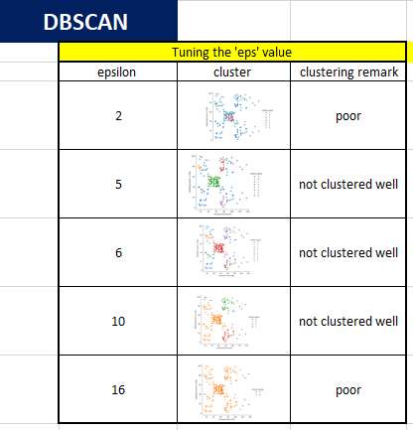

HDBSCAN clustering
The dataset was also analyzed using HDBSCAN (Hierarchical Density-Based Spatial Clustering of Applications with Noise).
Unlike DBSCAN, HDBSCAN does not require an epsilon parameter. The min_cluster_size parameter was tuned from 5 to 10, with 8 selected as optimal. min_samples was set to None.
The model produced 5 clusters along with several outliers, showing slightly better performance than DBSCAN.
Clustering quality was evaluated using a hdbscan validity index, yielding a score of 0.2.
Based on this analysis, this algorithm performing moderately
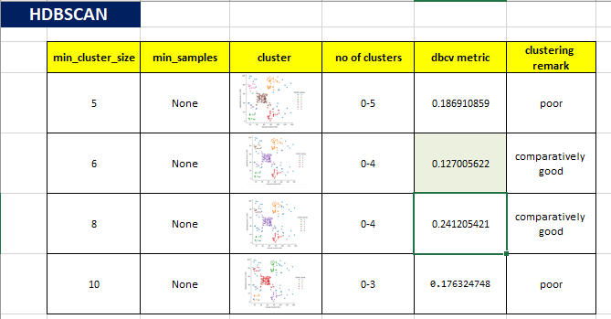

Mean shift clustering
The dataset was analyzed using Mean Shift clustering, where the key parameter bandwidth was estimated using estimate_bandwidth from scikit-learn with a quantile of 0.1, resulting in a bandwidth of 0.64.
The model was trained with bin seeding enabled for faster computation and produced 7 well-separated clusters.
Clustering analysis indicates that Mean Shift performs well on the customer dataset.
The final number of clusters can be adjusted based on domain-specific requirements for customer segmentation.

OPTICS clustering
The dataset was analyzed using OPTICS (Ordering Points To Identify the Clustering Structure), which does not require specifying the number of clusters.
Key parameters min_samples, xi, and min_cluster_size were tuned manually: min_samples=10, xi=0.01, and min_cluster_size=10.
The model produced 6 clusters along with many outliers, but the clustering was not well-separated.
Evaluation using the Davies-Bouldin score yielded 1.6, indicating poor clustering performance for the Mall Customer dataset.
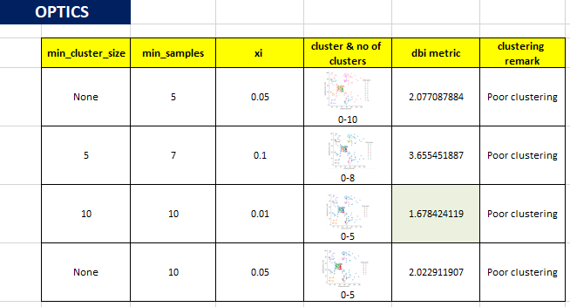

Spectral Clustering
The dataset was analyzed using Spectral Clustering with n_clusters=5 (based on domain knowledge), affinity='rbf', gamma=1.0, n_neighbors=10, assign_labels='kmeans', and random_state=0.
The model produced 5 clusters, but they were not well-separated, resulting in moderate performance.
Evaluation metrics showed a score of 0.4, indicating that the clustering quality is average.
Final cluster selection can be adjusted according to domain requirements.

Final model for mall customer segmentation
Based on the analysis of the Mall Customer dataset, the following clustering algorithms performed well for customer segmentation:
K-Means, Agglomerative Hierarchical Clustering, Affinity Propagation, and BIRCH (Bridge) Clustering.
These algorithms produced well-separated clusters and identified target customer segments effectively.
Other algorithms like DBSCAN, HDBSCAN, OPTICS, Mean Shift, and Spectral Clustering showed moderate to poor performance or produced many outliers, making them less suitable for this dataset.

Code GitHub Repo: https://github.com/krthiksha/Machine-Learning-Culstering

